**Submission to the Representation Commission – Review of Electoral Boundaries 2025**

**Submitted by: Philippa Beams, Onehunga resident**

Thank you for the opportunity to submit on the proposed changes to electoral boundaries as part of the 2025 Electoral Boundary Review. I appreciate the work of the Representation Commission in maintaining fair and effective representation across New Zealand.

**Understanding of the Current Proposal**

I understand that under the Commission’s initial proposal Maungakiekie gains population of 9,600 from Panmure-Ōtāhuhu in the north and south of the Panmure Inlet, and loses population in three areas to neighbouring electorates:

* Population of 2,200 is shifted from Maungakiekie to Epsom in Greenlane.
* Population of 300 is shifted to Epsom around Greenwoods Corner.
* Population of under 100 is shifted to Tāmaki from a small area in Mt Wellington.

The proposals are as a result of Maungakiekie needing to gain population, as it is currently 12.2% under quota.

I acknowledge the efforts made to balance electorates within the permitted population quota range. However, I respectively object and propose that three key amendments should be made to better reflect communities of interest, infrastructure links, natural geographic boundaries, and anticipated population growth.

**Proposed Changes**

**1. The population of 2,200 in Greenlane remains in the Maungakiekie Electorate  
  
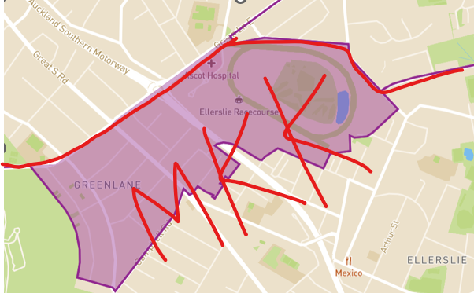**

* **Community of Interest:** This area has long-standing ties to the Maungakiekie electorate and reflects a cohesive and distinct community. Maungakiekie Avenue is the namesake of the electorate and One Tree Hill is an iconic local landmark. The proposal to exclude the streets surrounding the maunga severs them from the very community they most strongly identify with.

Notably, this area includes leasehold land owned by the Cornwall Park Trust, as does nearby Campbell Road, which remains in the Maungakiekie electorate. Retaining the full extent of this community ensures consistent and effective representation for leaseholders and the Trust, who share common interests and property arrangements. Likewise, this Greenlane area features a mixed-use character, with a blend of residential and commercial activity — particularly around Great South Road. This commercial corridor extends south through suburbs that clearly identify as part of the Maungakiekie electorate. Maintaining this continuity ensures the MP can effectively advocate for and represent the interests of the local business community, whose networks and economic ties extend along this shared arterial route.

Residents in this part of Greenlane commonly shop in Ellerslie Village, Onehunga, or Royal Oak (all of which are in the Maungakiekie electorate) — not in Remuera Village, Newmarket or Parnell. One Tree Hill/Cornwall Park itself is also a defining recreational and cultural feature, more frequently accessed and enjoyed by this community than any of the maunga within Epsom. This proximity and affinity are even highlighted in real estate marketing, which often references Cornwall Park as a key local asset.

Educational zoning further reinforces these ties. The area is zoned for St Mary’s, Michael’s Park, and One Tree Hill College, aligning it with schools located squarely within the Maungakiekie electorate. In contrast, the Auckland Grammar Zone — characteristic of Epsom — reflects a different demographic and schooling priority. These educational zones reinforce existing social groupings and patterns of association.

* **Infrastructure Links:** Greenlane residents in this area rely on shared infrastructure and amenities in Onehunga and Ellerslie, rather than Remuera or Newmarket. The Greenlane Train Station, located just south of Greenlane Road, serves many commuters in the current Maungakiekie electorate. Anyone north of Greenlane Road would take a bus or use the Remuera Train Station in the Epsom electorate. Additionally, Greenlane West is a natural boundary line given the nature of the arterial road i.e., no parking on either side, several lanes, leading to the motorway in both directions.
* **Topographic Feature:** One Tree Hill / Cornwall Park — is a unifying natural feature. It serves as a recreational and cultural anchor for the surrounding community, and helps define the identity of the Maungakiekie electorate. It makes little sense for streets encircling the maunga to be placed in a different electorate than the maunga itself.

**2. Maungakiekie gains population of 5,600 from Panmure-Ōtāhuhu, while the Tāmaki electorate gains remaining population of approximately 4,000 from Panmure-Ōtāhuhu.**

Instead of Maungakiekie absorbing the full population of approximately 9,600 from the Panmure-Ōtāhuhu area, I recommend adjusting the eastern boundary of the Maungakiekie electorate to follow Pilkington Road and Lagoon Drive, moving it westward from the Panmure Inlet. As illustrated by the red line below, this adjustment would, based on my calculations, result in approximately 5,600 residents being included in Maungakiekie and around 4,000 being incorporated into the Tāmaki electorate.  
  
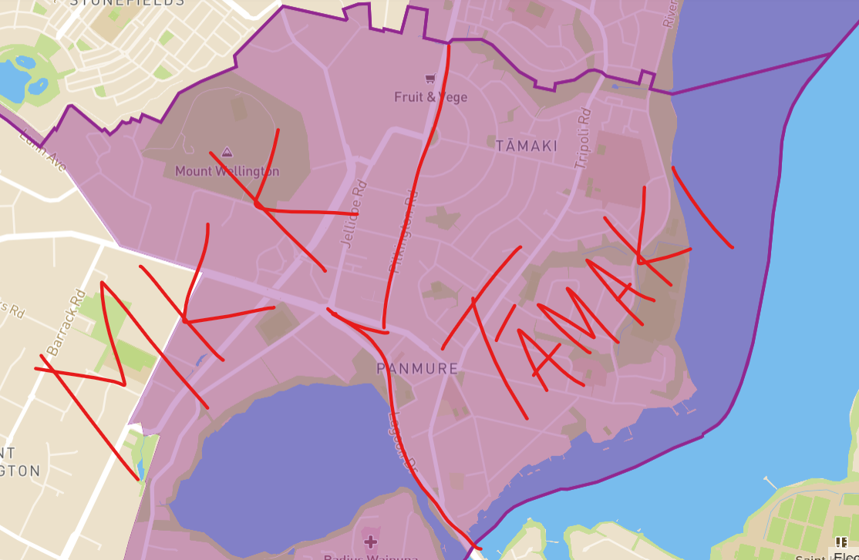

* **Community of Interest:** Panmure is socially, economically, and infrastructurally more aligned with the neighbouring suburbs of Point England and Glen Innes than with Mt Wellington or Onehunga. These three suburbs form the core of the Tāmaki area — a culturally diverse community undergoing significant urban regeneration led by the Tāmaki Regeneration Company. The issues affecting these communities are shared and interconnected: increasing provision of social and affordable housing, street and infrastructure upgrades, and support for growing populations through cohesive planning.
* **Infrastructure and Connectivity:** Panmure residents rely on shared local services and facilities with Glen Innes and Point England. For example, shopping and service use trends show a preference for Pak’nSave Glen Innes over Royal Oak or Sylvia Park. Public transport infrastructure reinforces this connection — direct bus and train links make travel between Panmure, Glen Innes and Point England more accessible than routes heading west toward Onehunga or Mt Wellington.

Shared use of community facilities, local parks, and schools reinforces the natural fit between Panmure and the Tāmaki area. Locating Panmure, Point England and Glen Innes within the same electorate would enable more effective representation by an MP who understands and can advocate across their common challenges, aspirations, and development pathways.

* **Topographic and Natural Boundaries:** The Tāmaki River (Te Wai o Taiki) serves as a clear and meaningful natural boundary that should be reflected in electoral mapping. Far more than a geographic feature, the river holds deep cultural and spiritual significance for all Mana Whenua. Historically, it functioned as a critical strategic transport route — easily navigable by waka, providing access to both the Waitematā and Hauraki on the east coast, and connecting to land portage routes leading to the Manukau Harbour on the west coast.

Given this significance, it is inappropriate to split the river and its surrounding communities across two separate electorates. Keeping the entirety of the Tāmaki River within a single electorate — the Tāmaki electorate — would honour its historical and cultural importance and better reflect the way the river continues to unify the communities along its banks, including Panmure, Point England, and Glen Innes.

I recommend the use of natural boundaries such as Pilkington Road and Lagoon Drive, which sit inland of the river and align with established infrastructure and urban form, to ensure Panmure and the Tāmaki area remains within one cohesive electoral boundary.

* **Electoral Identity and Clarity:** Placing Panmure in the Tāmaki electorate aligns with existing administrative and community boundaries, such as the Maungakiekie-Tāmaki Ward and the Tāmaki subdivision of the Maungakiekie-Tāmaki Local Board. It would also help avoid confusion for residents, especially newcomers, by aligning the suburb name of Tāmaki and electorate. Additionally, Panmure has historical precedent as part of the Tāmaki electorate, having been included between 1996 and 2005. Notably, the 2002 boundary followed Jellicoe Road and Lagoon Drive — just one street removed from the boundary alignment we are proposing in this submission today.

**3. Approximately 3,300 residents would move from Tāmaki into Epsom, as per the map below, to account for population lost through our Greenlane adjustment.**

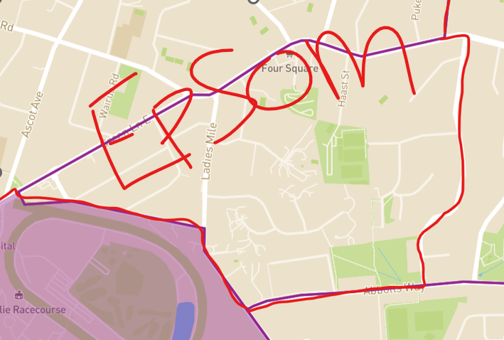

I acknowledge that the Epsom electorate requires population growth to remain within quota, and this realignment supports that need while also facilitating Proposal 1 above. The streets proposed to move into Epsom are more closely aligned with that electorate in terms of community identity and daily patterns of life. Residents in these areas are more likely to shop at local centres such as Countdown Greenlane, Remuera New World, or Lunn Avenue New World, rather than Eastridge, which is situated within the Tāmaki electorate and serves a different catchment. This shift reflects natural community connections and ensures more effective representation.

**Population Quota Considerations**Under the above proposed boundary adjustments, the population distribution would remain within the allowable electoral quota. Specifically, 2,200 residents would be returned to Maungakiekie from the Greenlane area (Proposal 1), while only 4,000 residents from Panmure would be added to Maungakiekie — rather than the full 9,600 proposed — with the remaining 5,600 shifting into the Tāmaki electorate (Proposal 2). To balance this, approximately 3,300 residents would move from Tāmaki into Epsom (Proposal 3), accounting for population lost through the Greenlane adjustment. Together, these adjustments would ensure Maungakiekie remains within the permissible population threshold — sitting right at the upper limit of the +5% margin — while maintaining community cohesion and planning for projected growth.

Under the Commission’s initial proposal, the Tāmaki electorate is nearly 5% under the population quota — twice as under-quota as Maungakiekie. Given this imbalance, it is practical for Tāmaki to absorb additional meshblocks such as Panmure, bringing it closer to quota compliance and providing more stable representation for its residents.

There is also a strong case for Tāmaki being closer to quota than Maungakiekie in this review round, as Tāmaki is not expected to experience the same level of population growth in the next five years. In contrast, Maungakiekie is poised for significant residential expansion, particularly in Ellerslie (including developments in and around the Ellerslie Racecourse), Onehunga (including the Oranga and Te Papapa regeneration projects), and Mt Wellington. Allowing Maungakiekie room to grow by realigning Panmure with Tāmaki is a future-proofed solution that supports long-term electoral stability and effective representation.

Thank you once again for the opportunity to provide input. I believe that these proposed amendments better reflect the reality of local communities and will result in more cohesive, practical, and representative electoral boundaries.

Kind regards,  
Philippa Beams