Get ready to enrol to vote



The Easy Read guide to enrolling to vote

VOTE HERE



Developed with input from

People First New Zealand, Ngā Tāngata Tuatahi





**1**

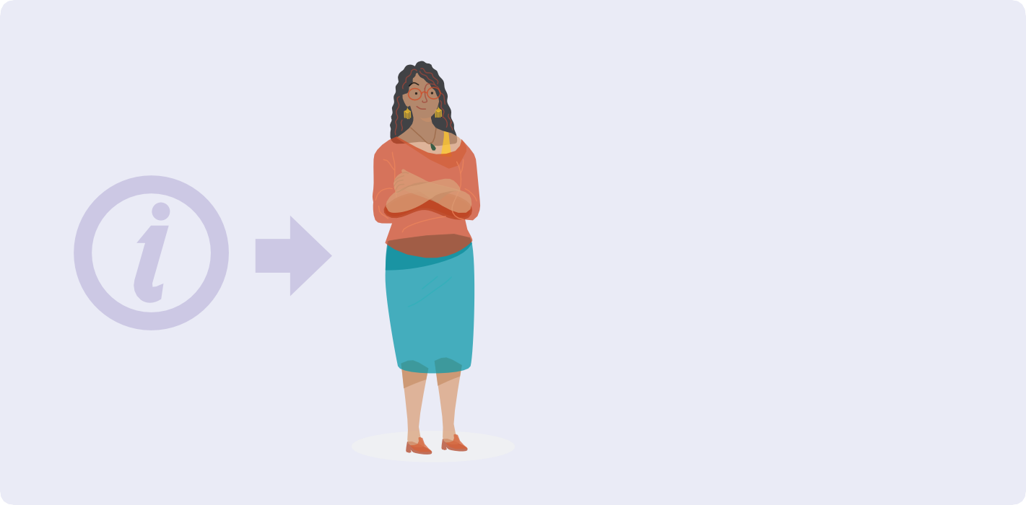

**About this booklet**

This booklet has information about how to enrol for a parliamentary election.



Usually all of New Zealand chooses all the people who will be in Parliament on the same day.

This is called a **general election**.

**2**



**About elections**

People in New Zealand vote for the people and parties who will:

* be in Parliament
* make decisions that affect your life.

**Parliament** is all the people and parties who have been chosen in the election.

Some of the parties in Parliament form the **Government**.



The **New Zealand Government** decides on things that affect your life like:

* schools
* hospitals
* roads.

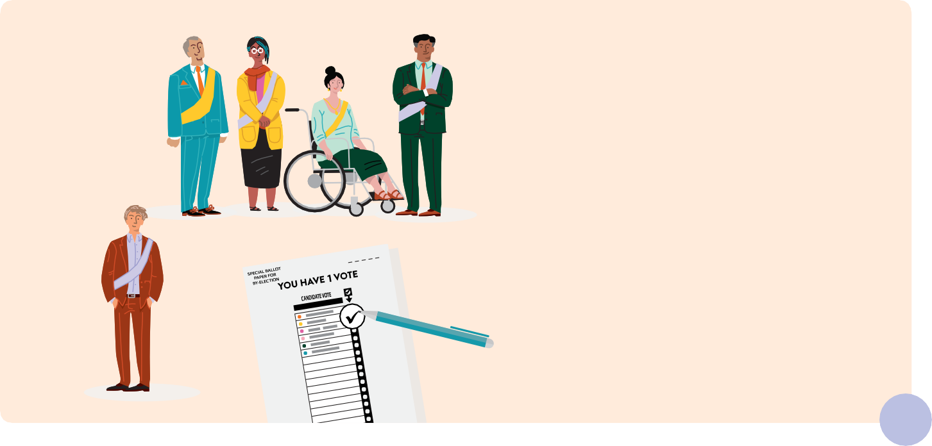

To choose a new MP a kind of election called a **by-election** is held.

If you live in the same local area you can vote for the new member of Parliament.

Your local area is called an

**electorate**.

**3**



**About elections**

The person who represents your local area in Parliament is called a **member of Parliament**.



Sometimes a member of Parliament needs to stop being in Parliament.

This might be because they:

* get a new job
* are very ill
* die.

This means there needs to be a new member of Parliament decided before the next general election.

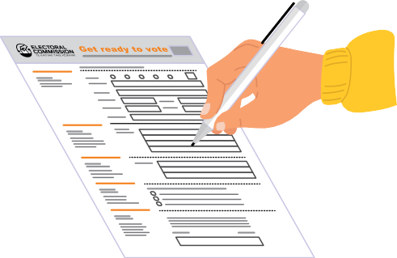

**About getting enrolled to vote**

You have to be enrolled to vote in a parliamentry election.

To get enrolled you have to fill in an enrolment form.

When you enrol your name will go on the **electoral roll**.

***ELECTORAL ROLL***

The **electoral roll** is the list of all the people who have enrolled to vote.

If you are Māori and enrolling for the first time you get to choose if you want to be on the Māori or the general roll.



You can change rolls any time after that, except in the 3 months before an election.



You can also enrol online at **vote.nz**

To enrol online you will need to use your:

* New Zealand driver licence or
* New Zealand passport or
* RealMe verified identity.

**4**



To get an enrolment form you can:

* call **0800 36 76 56**
* text your name and address to **3676**
* visit **vote.nz**.

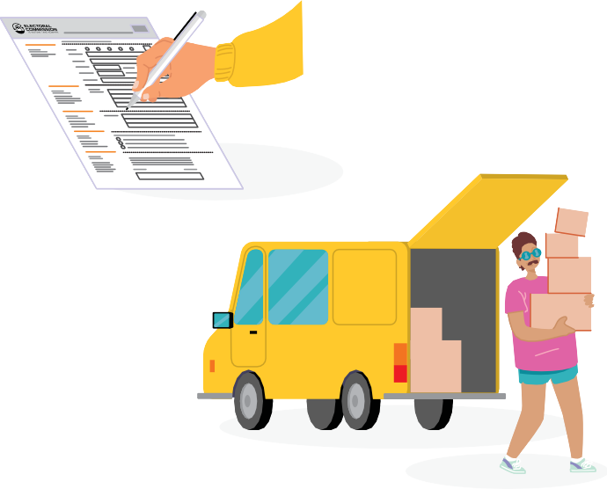

**Get ready to vote**

You must update your information on the electoral roll if you:

* move to a different place
* change your name.

**5**

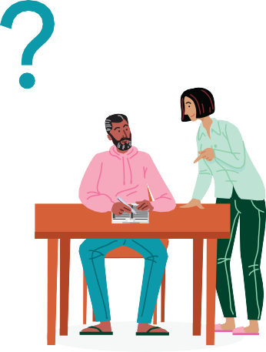

**About getting enrolled to vote**

***ELECTORAL***

The enrolment form will ask for information about you.

It is important to put the right information on the enrolment form.

After you have enrolled to vote your name will go on the electoral roll.

***ROLL***



***ELECTORAL***

***ROLL***

If you are worried about your safety if your name goes on the electoral roll you can ask to go on the **Unpublished Roll**.

Your personal details will not be given to anyone.

**Who can get enrolled to vote?**



***ELECTORAL ROLL***

In New Zealand you must

**enrol to vote** if you:

* are 18 years or older and
* have lived in New Zealand for more than one year at some time in your life and
* are a New Zealand citizen or permanent resident of

New Zealand.

**Get ready to vote**



VOTE HERE

PōTI I konei

You can enrol to vote any time:

* before election day
* on election day.

You can also enrol at a voting place when you go to vote.

**6**



Contact us if you have any questions about completing your enrolment form

* call **0800 36 76 56**.

**7**



**Enrolment support**

**1m**

You can ask a support person such as a friend or family member to help you complete your enrolment form, or to complete your form for you.



It’s best to enrol early as it makes voting much easier and faster but you can also enrol on election day.

Your support person can help you enrol at your local voting place or help you to enrol online.



34-42 Manners Street,

PO Box 3220, Wellington 6140.

E193 – March 2024



**More information about elections**

To get more information about how to enrol and vote in an election

* visit **vote.nz**
* call **0800 36 76 56**.